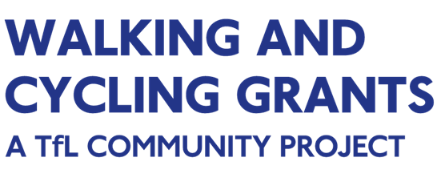
Guide to planning your project 2020

Application deadline: 5pm, Thursday 15 October 2020

Guide to planning your walking & cycling project

This guide will help you to plan your walking and cycling community project in a way that will meet the Walking & Cycling Grants London (WCGL) criteria as specified in the Application guidelines.
On behalf of Transport for London and The London Marathon Charitable Trust, Groundwork London has a dedicated grants team that works with applicants to develop project ideas and provide guidance and support throughout the grant process: from offering initial advice and ideas through to implementation and project completion. We also have teams of outreach officers who work with communities across London, so if there are particular groups and audiences you’re aiming to reach through your project, we can offer tailored support to help you achieve this.
Contact us
To discuss your project or any aspects of the application process:
wcgl@groundwork.org.uk
020 7239 1286
For further information visit:
@GroundworkLON
#walkcycleldn
Facebook.com/GroundworkLondon
www.wcgl.london

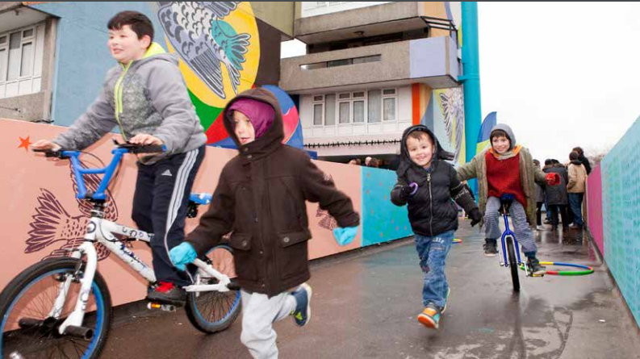

Contents
Guide to planning your walking & cycling project 2
Guide content 3
1. Walking & cycling activities 4
2. Engaging with people 5
3. Delivery plan and calendar 6
4. Information for walking projects 7
4.1 Route planing 7
4.2 Equipment 7
4.3 Getting to walks 7
4.4 Rewards 7
4.5 Additional activities 8
4.6 Infrastructure works/studies 8
5. Information for cyling projects 9
5.1 Cycle training 9
5.2 Bike maintenance training Error! Bookmark not defined.10
5.3 Purchasing and aquiring bikes Error! Bookmark not defined.11
5.4 Storage Error! Bookmark not defined.11
6. Additional funding, support and training 12
6.1 General…………………………………………………………………………………………………………12
6.2 Additional funding 12
6.3 Advice 12
6.4 Training and knowledge sharing 13
7. Delivering your project during Covid-19 13
8. Insurance 14
9. DBS checks (formerly CRB) 15
10. Useful Links 15

1. Walking & cycling activities
There are a diverse range of activities that you can deliver to encourage members of your local community to walk or cycle. As part of developing your project idea, it is important that you identify the participant groups that you would like to work with, consider what barriers to walking or cycling they may have, and tailor the activities offered to best support them. Different groups are likely to have different needs.
Access to a bike | Refurbished, old or abandoned bikes can be sold at affordable prices, or setting up a local bike hire scheme can be a way to increase cycling access in your community.
Lack of confidence | Cycle and walking training can increase confidence. WCGL will offer training to successful projects, for example ride leader training for cycling, and training on how to lead a walking group, as well as breathing and stretching exercises etc.
Knowledge  of local routes | Offering group walks or rides is a very good way to show people where they can walk or cycle in their local area. You can find the seven routes of the Walk London Network at tfl.gov.uk/modes/walking/top-walking-routes and links to leisure routes, maps, cycleways at tfl.gov.uk/modes/cycling/routes-and-maps
Bike maintenance skills | Often people stop cycling when they get a puncture or their brakes stop working. Learning how to do basic repairs can support people to look after their bikes and resolve minor problems for themselves therefore saving money and keep cycling for longer.
Cultural aspects | Consider the cultural needs of the participants that you will be working with. For instance, if they speak a language other than English, ensure you can communicate with them in that language. You may want to think about how beneficiaries might feel about walking or cycling and if there is a way you can promote walking or cycling in your community so that it is seen in a more positive light?
Time and work constraints | Think of whether your participants may have work or family commitments and how your activities can be planned around these. For instance, will attendance be higher if activities are delivered during the day, in the evening or at weekends? Should you be offering a crèche for children?
Lack of walking equipment | When people want to start walking as an activity, they may feel they need to upgrade their shoes and socks, and get some specialist equipment, such as poles, pedometers, and rucksacks etc., or to get technology to help them such as apps or maps. Consider offering this equipment to your participants, if relevant to your activities
Mobility impairment and lack of fitness | Consider whether the mobility or fitness of your participants may require the use of special walking shoes and clothes, or non-standard cycles, such as ability bikes, to enable access to cycling. You may have to plan routes to factor an impairments as well, such as shorter routes, avoiding inclines, level ground, or wider paths
A list of some common barriers to walking and cycling and ideas of activities to overcome them are listed below.
We recommend that you view examples of previous projects’ activities by visiting the case studies section on our website. Please note, these will just be for cycling related projects:
https://wcgl.london/casestudies
Alternatively visit the Community ideas hub, where you will find information about previous projects which could be easily replicated elsewhere in London:
https://wcgl.london/communityideashub

2. Engaging with people

Perhaps you want to organise a group walk or cycle with your local community, go on a guided nature walk, refurbish second-hand bikes, take people on sensory or mindfulness walks, or train participants in new bike maintenance skills. Whatever you think your area or community group might need the simplest way to gain support, recruit volunteers and find out what people want to get involved with, is to ask the people who live near you. Ask your friends, family and neighbours, or parents at your local school what activities would help them to get out walking or cycling, and what the issues might be that stand in their way, that your project could help overcome.
You could also find out local opinions and get support and ideas of activities to offer by asking local community forums, schools, youth groups, older people’s groups, disability forums, community centres and faith groups. You can do this using social media or by putting up posters to advertise your ideas or to recruit volunteers in local shops and supermarkets, libraries, community and leisure centres, even in the local pub.
When working with your participants or volunteers, ensure that you:
- Introduce them to the project and give a clear idea of what you’re trying to achieve
- Provide a safe environment: make sure any risks are identified, minimised and covered by adequate insurance
- Offer support: if you have a large project, you could name supervisors to take responsibility for giving groups the support they need
- Resolve difficulties: make sure your volunteers know where to raise any concerns or problems
Ensure that everyone feels welcome to participate
- Follow the government guidelines around obtaining DBS certificates and safeguarding measures to put in place; www.gov.uk/government/organisations/disclosure-and-barring-service
Follow the latest government guidance on delivering projects during the Covid-19 pandemic: www.gov.uk/coronavirus

3. Delivery plan and calendar
Once you have decided on your project idea, you need to plan the delivery of your activities and produce a realistic calendar.
Your calendar should include all the activities necessary for the successful delivery of your project:
- Setting up activities: Do you need to set up a workshop space, buy tools or hire equipment? How long will this take?
- Training of staff and volunteers: Are staff and volunteers of your project going to attend training in order to deliver the project? If so, you need to think about when and where the training will take place, making sure that it happens at an appropriate point.
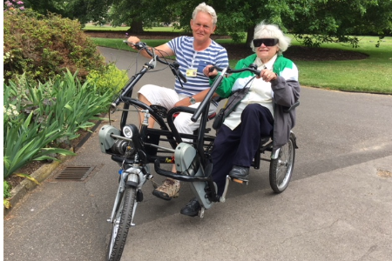
- Outreach and communications: Make sure you plan enough time to communicate your project and engage with your beneficiaries. Working with groups you haven’t worked with before will require more time and resources than engaging with a well-established group of beneficiaries.
Delivery of activities: How many sessions or events are you going to deliver and when? Is the timeline realistic and achievable?
- Reporting: You will need to plan monitoring of your project whilst it is being delivered but also allocate some time at the end to make sure you produce your final report and any evaluation work within the required timeframe.
WCGL calendar
It is really important that you familiarise yourself with the WCGL calendar and the grants’ payment and spending dates (both can be found in the Application guidelines) and that you plan your project calendar accordingly.

4. Information for walking projects

There are a broad range of walking activities that would be eligible for grant funding. Walking projects could include discovering local areas and parks, helping to reduce social isolation or getting people more healthy and active.

4.1 Route planning
One barrier that people may face is not knowing how to plan walks around the areas in which they live. You may wish to run a project which takes people on led walks, but also gives them the tools to plan and undertake their own walks in their local area.
You can find lots of walking routes & Maps on the TfL website:
tfl.gov.uk/modes/walking/
Quick walks between stations:
https://londonblog.tfl.gov.uk/2020/07/16/station-walks/?intcmp=62534
West End walking map:
http://content.tfl.gov.uk/walking-times-and-steps-shops-attractions-west-end.pdf
Go Jauntly walking maps on your phone:
www.gojauntly.com/blog/2018/11/28/go-jauntly-version-2?intcmp=56645&intcmp=56822
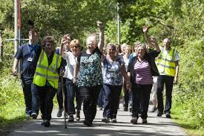

4.2 Equipment
Whilst planning your project, you should think about what equipment you might need to purchase to ensure there are no barriers for people taking part. This could include things like waterproofs, walking poles, backpacks and pedometers.
You should also consider how to store any equipment, and whether you will need an indoor venue for any activities, such as route planning workshops.

4.3 Getting to walks
Walking projects are a great to explore your local area. You may wish to take your project participants to different parts of London. To do this you will need to consider how to transport them. You should aim to make this as environmentally friendly and risk free as possible whilst being suitable for the participants you hope to engage with.

4.4 Rewards
A good way to engage people in activities is to provide a reward for taking part. This could be earning walking equipment, to enable them to continue after the project has ended.

4.5 Additional activities
You may also wish to combine walking activities with other activities to add interest, e.g. a walk around a local area that involves discussing local history, a walk that culminates in a park where you have arranged some games or crafts, or a walk to somewhere that participants can relax and socialise. You should ensure that the cost of these additional activities are a small proportion of the costs of the project – the majority of costs must be connected with walking.
You will also need to operate within up-to-date government guidelines on maximum group sizes and social distancing restrictions during the Covid-19 pandemic: www.gov.uk/coronavirus

4.6 Infrastructure works/studies
Please note that WCGL will not fund any infrastructure works for walking, or studies/activities which aim to assess where such works may need to be undertaken. We suggest that where you may have identified a need for such works you should contact the public body who is accountable for that location.

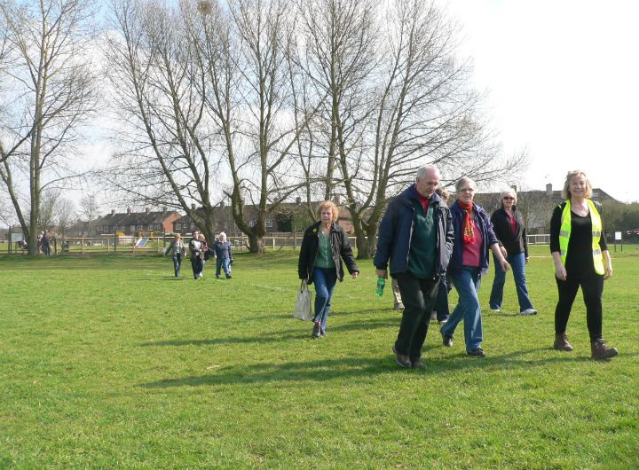

5. Information for cycling projects

5.1 Cycle training
It is important that cycle training is offered to all participants in cycling projects. This is so that they can be taught the basic cycling control and safety skills for their personal cycling development. All cycle training should follow the guidance in the National standard for cycle training issued by the Department for Transport:
www.gov.uk/government/publications/national-standard-for-cycle-training
Your project can directly offer cycle training or signpost participants to undertake free Cycle Skills sessions offered by London boroughs. Before including the cost of cycle training in your funding application, check if any of these can be funded by your borough council: tfl.gov.uk/forms/12421.aspx
You can also brush upon your cycle skills with the free TfL online cycle skills course:
cycle-skillsonline.tfl.gov.uk

Cycle training offered through your project
If you decide to provide cycle training through your project, you can either (a) train your own instructor or (b) work with external training providers.

a) In-house cycle training – train your own instructor(s):
To become a cycle instructor you will need to complete a four-day practical course in instructing cycle training delivered by a 1st4sport Recognised Delivery Centre (RDC), pass a half-day post course assessment and register on the Bikeability Trust instructor database. You will need to be a competent cyclist before attending this course.
You will need to renew your registration each year, so you will need to factor this into your budget.
For information about instructor cycle training and registration on the Bikeability instructor database visit:
https://professionals.bikeability.org.uk/
You may choose to start your project working with external cycling instructors while training one or more of your own staff who can take over the cycle training sessions once they have completed their training. This is an ideal way to ensure your project is sustainable beyond the WCGL grant, by upskilling staff.
Please contact your chosen training provider to obtain a quote to make sure you are budgeting for the right amount.

b) External cycle training providers for groups:
You are encouraged to check with your local borough if they can provide an instructor for the cycle training sessions you will be delivering through your project. If this option is not available to you there are a variety of Cycle training providers in London:
Bikeworks
http://www.bikeworks.org.uk
Cycle Confident
www.cycleconfident.com/
Cycling Instructor
www.cyclinginstructor.com/
Cycle Experience
www.cycleexperience.com

5.2 Bike maintenance training
You need to ensure you have enough resources to maintain bikes in a safe working order throughout the project and beyond. You can apply for funding to train individuals within your organisation or work with a service provider to deliver bike maintenance sessions and maintain the project owned bikes. Mechanic training providers in London include:
London School of Cycling:
www.londonschoolofcycling.co.uk/content.php?id=15
London Bike Hub:
https://londonbikehub.com/maintenance-training/
Cycle Confident:
www.cycleconfident.com/courses/maintenance/
Bikeworks
www.bikeworks.org.uk
There are two kinds of mechanics training:

a) General training:
This covers a wide range of courses from essential maintenance (covering puncture repair and brake and gear maintenance) to more advanced courses. Different training providers offer a variety of courses and levels of training. Please check the providers’ websites for more details and to decide which is the most adequate level of training that your mechanic(s) will need.

b) Professional training:
There are two kinds of professional mechanics training, City and Guilds and Cytech (both include three levels of accreditation). These are more in depth and more expensive courses. Please consider whether this level of training is necessary for the activities that your organisation will be developing. This course is recommended for projects running a build-a-bike scheme or restoring bikes to roadworthy condition.
As an alternative to carrying out maintenance work yourself, you may be able to partner with a local bike shop or community cycle centre to agree a reduced rate for repairs. However, you will still need at least a few of the project delivery team to have basic maintenance skills such as fixing punctures, adjusting seats, tightening brakes etc.

5.3 Purchasing and Acquiring Bikes

Several ways you can get bikes for your project are below. However you source your equipment, always make sure that the quality and type of bike is appropriate for your project.

Donated / unwanted bikes
There are a number of sources from which you may be able to source bikes for free. In previous years groups have obtained bikes from:
- The Police (stolen and abandoned bikes which are not claimed) or the local council
- Donations from the public
- Discarded bikes at refuse sites
You may find that bikes need repairs and/or reconditioning prior to use in your project. If your group does not have the skills to carry out those activities, you may be able to partner with a local bike shop or community cycle centre to have essential works completed at reduced rates or for in-kind payment, such as offering promotion for them, or signposting to their organisation for your participants.

Second-hand bikes
Ask for proof of ownership before purchasing second-hand bikes, that way you can ensure that the bikes are from a reputable source and are less likely to have been stolen. Bike shops can provide you with second-hand bikes that have been fully serviced and you can be sure the bikes are in roadworthy condition.
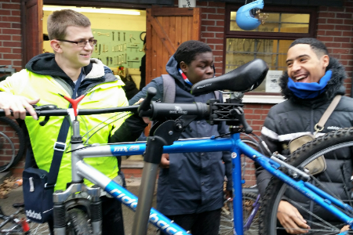
There are a number of local community bike shops that recondition donated or unwanted bikes, which they are able to sell at low prices. Many of these will also undertake repairs at low prices.
The following organisations provide useful information on recycled bikes and recycling:
London Community Resource Centre
www.lcrn.org.uk
London Re-use Centre
http://lcrn.org.uk/projects-services/london-re-use-network/

New bikes
It is possible to purchase new bikes with your WCGL funding. The grant can cover the cost of standard bikes up to £500. When needed, non-standard bikes such as trikes, tandems and cargo bikes, may be purchased at higher rates. If you need further guidance on this, contact the grants team at wcgl@groundwork.org.uk or on 020 7239 1286

5.4 Storage
Before purchasing bikes for your project, it is important to consider where you will store them. Most insurance providers may require that they are locked in a secure place but please do check your policy to ensure that you are adequately covered.
Garages, secure lockups and other storage areas are an option, and a variety of bike storage designs are available.
Please note that WCGL does not fund cycle parking equipment such as racks.
Applicants to WCGL should consider including bike storage costs in their funding proposal if required.

6. Additional funding, support and training

6.1 General
Walking and cycling are easy ways to get around in London and have huge mental and physical health benefits too. Here are some general resources which detail the changes and opportunities taking place:
- Cycling and walking investment, grant funding, research and infrastructure case studies:
www.gov.uk/government/collections/cycling-and-walking

- TfL’s Walking webpage:
tfl.gov.uk/modes/walking/

- TfL’s Cycling webpage:
tfl.gov.uk/modes/cycling/

6.2 Additional funding
There are a range of resources available to assist you in finding additional funding, for example:
- Funding Central is a free resource which lists thousands of funding and finance opportunities:
www.fundingcentral.org.uk

- The National Lottery’s funding finder tool can help identify the most suitable funding programme for your project. https://www.lotterygoodcauses.org.uk/funding

- Borough cycling officers or Community Voluntary Service (CVS) will be able to advise of any other funding available locally.

You may also be able to secure funding from businesses. For larger organisations you should contact their Corporate Social Responsibility (CSR) team.

6.3 Advice
The following organisations can provide information on a number of different topics, from project accounting to fundraising techniques:

- Directory of Social Change provides information and training for charity organisations, including training on fundraising:
http://www.dsc.org.uk/

- VolResource provides information for voluntary and community organisations:
www.volresource.org.uk

- NCVO champions the voluntary sector and provide guidance to support charities, community groups and social enterprise:
www.ncvo-vol.org.uk

- Charity Commission is the regulator for charities in England and Wales: www.charitycommission.gov.uk/start-up-a-charity

- Co-operatives UK produces guides to legal, financial and organisational aspects of running not-for-profit organisations: www.uk.coop/simplylegal

6.4 Training and knowledge sharing
Groups that are awarded grants will have the opportunity to attend free training on a range of subjects. Each group will have the opportunity to send at least one individual on any of these courses. Training available may include:
- Bike mechanics
- Engaging your community
- Stretching and breathing techniques
- Route planning (walking or cycling)
- Marketing and communications
- Finance and accounting
- Project management
- Further fundraising
- Volunteer management

Spaces on courses will be limited, but we will try to ensure that as many groups can benefit from the training as possible.

In addition to formal training, we also facilitate knowledge and resource sharing between successful groups. You will be invited to join the WCGL Facebook group, there will also be opportunities for face to face networking with other projects.

The Community Ideas Hub on the WCGL website provides project ideas and inspiration, advice, resources and guides for running a project efficiently and successfully:

https://wcgl.london/communityideashub

7. Delivering your project during Covid-19

It is likely that social distancing and other public health measures introduced to combat the spread of COVID-19 may continue for some time, potentially for the whole duration of some projects funded through WCGL. It is imperative that all projects always follow the latest public health guidance. The latest COVID-19 updates and guidance can be found at www.london.gov.uk/coronavirus.

With appropriate precautions and adjustments in place, projects can be delivered safely. Resources are available providing advice on using green spaces, working outside and volunteering during the COVID-19 pandemic. The resources listed below are accurate as of July 2020, however please check these websites frequently for the latest updates.
Guidance on using London’s parks and green spaces:
www.london.gov.uk/coronavirus/social-distancing-guidance/london-parks-and-green-spaces-covid-19-guidance
Advice and guidance from Ramblers:
www.ramblers.org.uk/coronavirus
NCVO guidance and resources to support charities, voluntary organisation and volunteers:
www.ncvo.org.uk/practical-support/information/coronavirus

8. Insurance

It is critical to have adequate insurance for your project and any equipment you will be purchasing.
Public Liability insurance covers claims that could be made by members of the public or for incidents that could occur in connection with your project activities. This insurance covers the cost of claims for personal injuries, loss or damage to equipment or property and is therefore vital to projects of this kind.
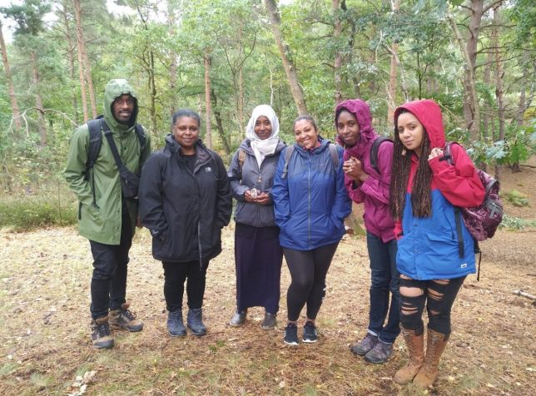
If you’re buying bikes that are going to be part of a pool you’ll also be required to insure them. You will need to do some research to find a good deal and a policy that will cover your needs. You may be able to get a combined policy that covers your public liability insurance and your equipment (eg bikes and tools).
VolResource Insurances Services provides Information on different insurance companies: www.vr.volresource.org.uk/services/insurance
We encourage you to get quotes from a few different providers to find the best deal.

9. DBS checks (formerly CRB)

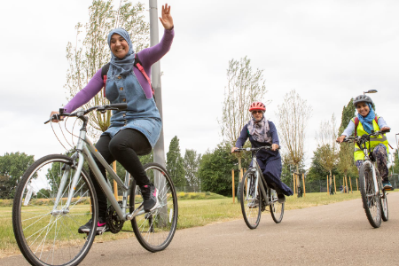
For projects involving children and/or vulnerable adults, your organisation must have a safeguarding policy, and DBS checks are a requirement for all trainers, helpers, and anyone else working with these participants. Further information to obtain these check can be found at: www.gov.uk/disclosure-barring-service-check/overview
Please also note that you should consider including any costs related to this in your budget.

10. Useful links

TfL website
Walking webpage:
tfl.gov.uk/modes/walking/
Cycling webpage:
tfl.gov.uk/modes/cycling/
Walking and cycling through Experience London blog:
https://londonblog.tfl.gov.uk/

Use TfL routes and maps to plan your walking or cycling route:
tfl.gov.uk/maps

Walking Organisations
Ramblers
www.ramblers.org.uk.

The Long Distance Walkers Association:
www.ldwa.org.uk
Walking for Health, England’s largest network of health walks:
www.walkingforhealth.org.uk
A list of Walking Clubs in London:
www.ramblingclubs.com/index.php/listings/tag/rambling-clubs-in-london

Walking training plans
British Heart Foundation walking training zone:

www.bhf.org.uk/how-you-can-help/events/training-zone/walking-training-zone
London to Brighton Challenge training plan
www.london2brightonchallenge.com/uploads/17-london-2-brighton-challenge-walkers-training-1.pdf
Walk the Walk Training Plans:
www.walkthewalk.org/training/training-plans

Walking guides and events
British Heart Foundation find a walking group:
www.bhf.org.uk/informationsupport/heart-matters-magazine/activity/walking/walking-groups/find-a-walking-group
Go Jauntly Walking maps for London:
www.gojauntly.com/blog/2018/11/28/go-jauntly-version-2?intcmp=56645&intcmp=56822
Self-guided London walks:
www.walklondon.com
Saturday walkers club provide free-to-use public transport friendly walks:
www.walkingclub.org.uk
Time Outdoors provides advice and listing of events:
www.timeoutdoors.com/events/walks

Cycling Organisations
British Cycling:
www.BritishCycling.org.uk

London Cycling Campaign:
www.lcc.org.uk

Sustrans:
www.sustrans.org.uk

Cycling UK:
www.cyclinguk.org

Bikeability Trust
www.bikeability.org.uk

Cycle Training
TfL Cycle Skills Portal:
www.tfl.gov.uk/modes/cycling/cycle-skills
Cycle Skills training through your borough:
www.tfl.gov.uk/forms/12421.aspx
TfL online Cycle Skills course:
cycle-skillsonline.tfl.gov.uk
Bikeability instructor training:
https://professionals.bikeability.org.uk/

Cycling events in London
Ride London:
www.PrudentialRideLondon.co.uk

Bike Week:
www.cyclinguk.org/bikeweek
Tour of Britain:
www.TourofBritain.co.uk
London Cycling Campaign events:
www.lcc.org.uk/events

Maps & Route planning
West End walking routes:
http://content.tfl.gov.uk/walking-times-and-steps-shops-attractions-west-end.pdf
Walkit best walks in London:
https://walkit.com/london/
Route you walking and cycling route planner:
www.routeyou.com/en-gb

