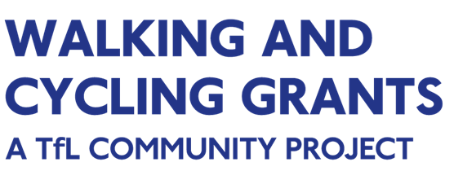

Online application
user guide 2020

Application deadline: 5pm, Thursday 15 October 2020

Introduction to this user guide

This guide takes you through the process of registration, logging in, site navigation, completing and submitting your application. It should be read alongside other guidance documents including the application guidelines and the model application.

You apply for Walking and Cycling Grants London (WCGL) through a portal called ‘GIFTS’. This system will help you to manage your application by providing a dashboard where you can view the status of your application and guidance documents in one place.

You will be able to save and come back to your application form before you submit it and receive updates on the status of your application. GIFTS will also allow us to provide you with support throughout the process.

1. Registration

To apply online, you do so through the WCGL website.
Navigate to the How to apply tab under Applying, and follow the steps.
You will be asked to enter your email address and a password to create your account. A verification email will be sent to your email address once you have completed your registration. Please check that you have received this before starting your application.
To ensure that you receive all correspondence relating to your application, please save the following email address within your contacts: mail@grantapplication.com
2. Logging in

Once registered, you can log in to your dashboard area by clicking on the link provided in your verification email. You will be asked to enter your email address and password. If you have forgotten your login information you can reset your password by clicking on the ‘Forgot your password?’ link.
Once logged in, you will be able to access your dashboard where you will find your In progress application.
3. Dashboard

Your dashboard will display all applications that you have started, and those that are in progress. The image below is an example of what you will see once you have logged into your account:
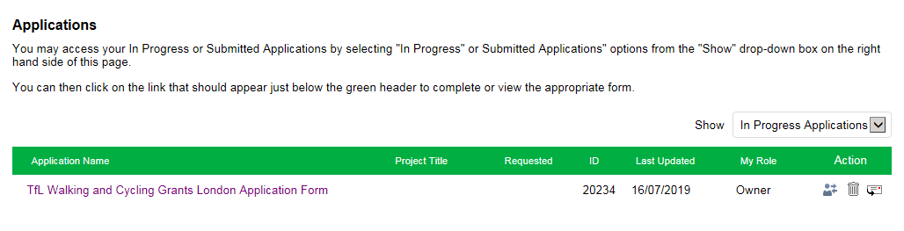

To access an application that you have worked on previously, select ‘In progress applications’ from the drop-down menu at the top right hand side of the page. You can also see submitted applications using this drop-down menu.
4. Applying online

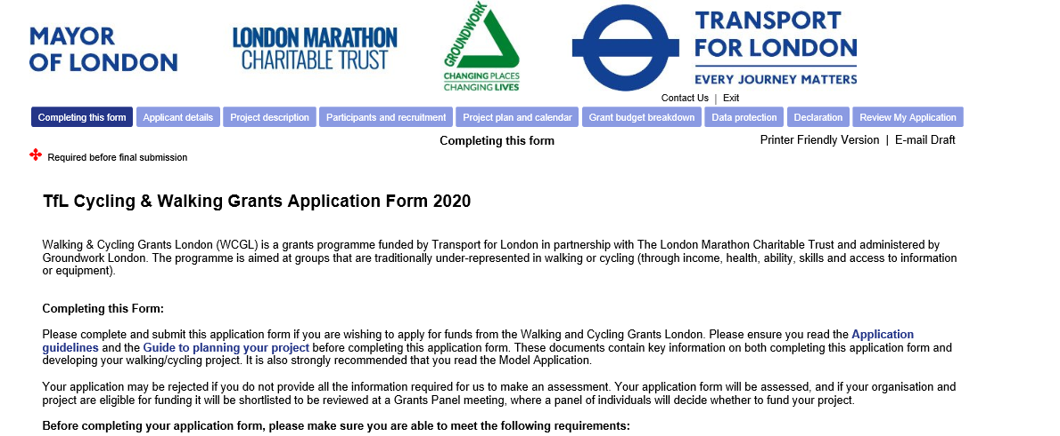
The online application form has eight sections
- Applicant details
- Project description
- Participants and recruitment
- Project plan and calendar
- Budget breakdown
- Data protection
- Declaration
- Submission
You need to complete each section in this order, moving onto the next section once you have completed and saved the previous one. You can browse through all sections to see all the questions at any time.
At the end of each section, you will see the ‘Save and finish later’ and ‘Next’ buttons. The ‘Next’ button will automatically save each section once all sections marked with an asterisk (*) have been completed, and allow you to move onto the next section.
To save your application and come back to it later, simply select the ‘Save & finish later’ button. This will take you out of the form and back into your account page.
If you select the ‘Exit’ button at the top right hand corner of the page you will be logged out of your account and taken to Groundwork London’s landing page. If this happens, you will need to log back into your account to complete your application.
Always click the ‘Save and finish later’ button before hitting the ‘Exit’ button to avoid losing your work.
You can edit your responses in any completed sections by re-entering the details and saving the section again. Once you complete the ‘Declaration’ section (part 7), you can review your answers before submitting the form. Once submitted, your application can no longer be edited.
Once you have submitted your application its status will be changed to ‘Submitted’. You can log in to your account and view this application within your dashboard at any time. You will need to use the drop-down box shown in section 3 ‘Dashboard’ to view your submitted applications.
6. Help

Guidance and supporting documents are available to download from the Resources page on the website. We advise that you review these before starting your application.
For some questions, additional explanations are provided. Click on the ‘question mark (?)’ button beside the question to see further information on the response required. If this is the first time you’ve applied to WCGL it is advisable to read all the question hints for a better understanding of the questions.
7. Log out

To log out of your session, click on the ‘Exit’ button on the top right corner of the website but remember that your application won’t be saved unless you click ‘Save and finish later’ button before you exit.

Please note that if your session has been inactive for a period of 90 minutes or more you will be logged out automatically. It is advisable to save your application regularly to avoid losing any completed sections.
The deadline to submit your application is 5pm, Thursday 15 October 2020

