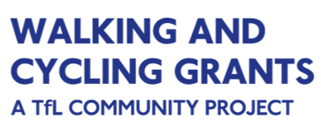

Risk Assessment 2022

Application deadline: 10.00, Monday 12 September 2022

Activity/event description
Date, time and address of activity/event |  | Number of participants expected
Does the location have a health and safety policy, emergency operating procedures? |  | Are there any particularly vulnerable participants (e.g. children, old people etc.)
First aider name |  | Number of staff and volunteers booked
First aider contact number on day of activity/event |  | Location of first aid kit

Identification of hazards and who may be harmed | Risk Level |  |  | Precautions to remove hazard, reduce risk level | Risk level after implementation of control procedures
 | Low | Med | High |  | Low | Med | High
(add more rows if needed) |  |  |  | (add more rows if needed)

Date of risk assessment |  | Assessment Review Date
Completed by |  | Completed by
Signature |  | Signature

Hazard Checklist Example (please note that this is not an exhaustive list of kinds of activities and/or hazards)
Group Bike Rides / Cycle Training / Guided or Led Walks
Road crossings |  | Un-roadworthy bicycles |  | Weather conditions
Sharing route with other users |  | Lost riders/walkers |  | Children
Poor surfaces |  | Poor Health/Fitness |  | Other
Maintenance workshop
Handling tools |  | Handling oils and lubricants |  | Other
Lifting bikes |  | Slippery surfaces

